Code Review: I2304099
Reviewer: Mark Dell
Date: July 5th, 2023

Bugs
- You changed the case of some words on several lines to proper case. Some are in comments, but some are SQL statements (On, In, …). In at least one case, (the second example) this is a breaking change. I feel it would be preferred to modify TFS such that the history is virtually like it never occurred using a rollback, although that may be a little heavy handed, and I do not believe it is possible in this case because other changes have already been made to that file. In addition, these changes have already made it to the release branch.
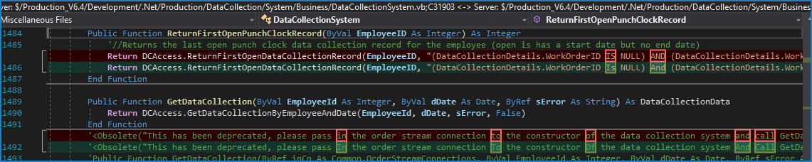

Preventative Action/Safety

Design/Architecture (Duplication, appropriate project, namespaces, maintainability)

Data Model (Naming, good design, needs index?)

Performance (Minimize DB hits, excessive loops, queries, scalable)
- Nit: Specifying the loop variable with the Next keyword is not needed, and in VB6 degrades performance. There are multiple instances of this.
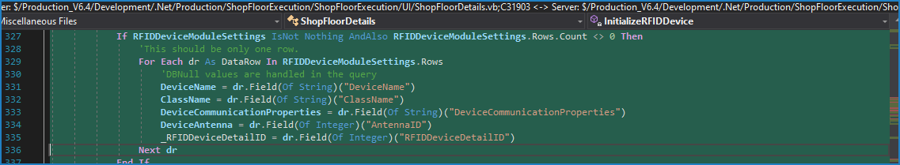

UI (Alignment, naming, standardization, tab order)

Error Handling (Behind events, appropriate parameter checking)

Cleanup (Dispose code, remove handlers, large data objects)

Readability (Well-named variables, methods, clear algorithm, is it understandable)
- When using a command builder for a data adapter, it is not necessary to set the data adapter’s insert command as it will be done automatically which overwrites any changes a developer might make. Doing that is only useful if the command is cloned and the command builder is disconnected from the data adapter before the data adapter update is performed.
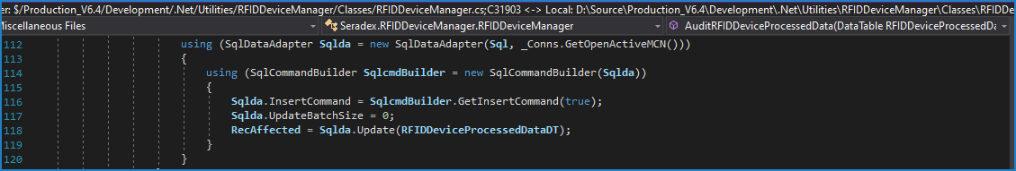
- Nit: We usually include blank lines around each block of an If statement, and after the End If, not before it, and not for the start or end of the entire If when there is an indentation change. There are other examples.
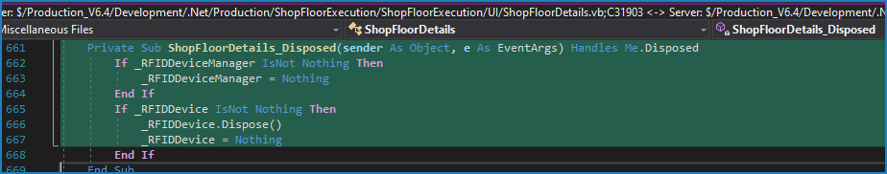

Comments (Useful, explains why rather than how)

Message Boxes (Grammar, spelling, captions, appropriate icons)

Ticket Management (Release Branch?, Testing Notes)
- These changes are already in the release branch with other changes in the same assemblies in testing that are bound for release, but the Forecasted Release Cycle is set for after August 11th, 2023, which is the current scheduled release date.

Extras
- Nit: Using a data adapter to simply load data, although simpler, is a bit heavy handed, and removes control over the data reader it uses internally. I suggest using a command and reader instead.
